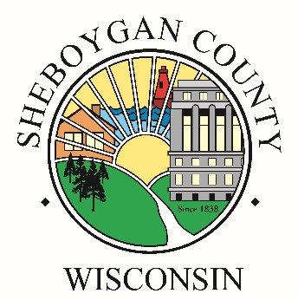

Sheboygan County Community Mass Testing Events

In partnership with Sheboygan County Emergency Management and the WI National Guard, Sheboygan County Division of Public Health is planning to hold mass community testing events at the Sheboygan County fairgrounds.

**Testing Dates and Times Open to the Public** **Location**

Thursday, May 28th, 2020 from 11-7pm Plymouth Fairgrounds

Friday, May 29th, 2020 from 11-7pm 229 Fairview Drive, Plymouth

Saturday, May 30th, 2020 from 8-4pm

**General Information about Community Testing Events:**  
● No appointment is needed for the testing  
● Testing is free  
● Testing will be done at the fairground and per drive-thru  
● Daily testing capacity will be 400 tests  
● Members of the Wisconsin National Guard will conduct the testing  
● Testing is available for those ages 5 and older but minors must be accompanied by a parent or guardian who can consent to the testing  
● The test determines if you currently have COVID-19 and is NOT an antibody test to tell if you have had it in the past or have immunity.

**Testing is available for anyone with symptoms:**  
● Fever, defined as a measured temperature greater than 100.4°  
● Cough  
● Shortness of breath or difficulty breathing  
● Sore throat  
● Headache  
● Chills or rigors (repetitive shaking chills)  
● Myalgia (muscle aches)  
● New loss of taste or smell